2017 Girls Basketball Final

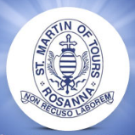

St Martin of Tours 39 defeated Pascoe Vale South 9

2017 Boys/Mixed Basketball Final
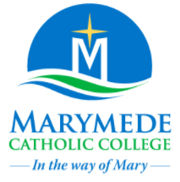
Glen Katherine 33 defeated Marymede 20

